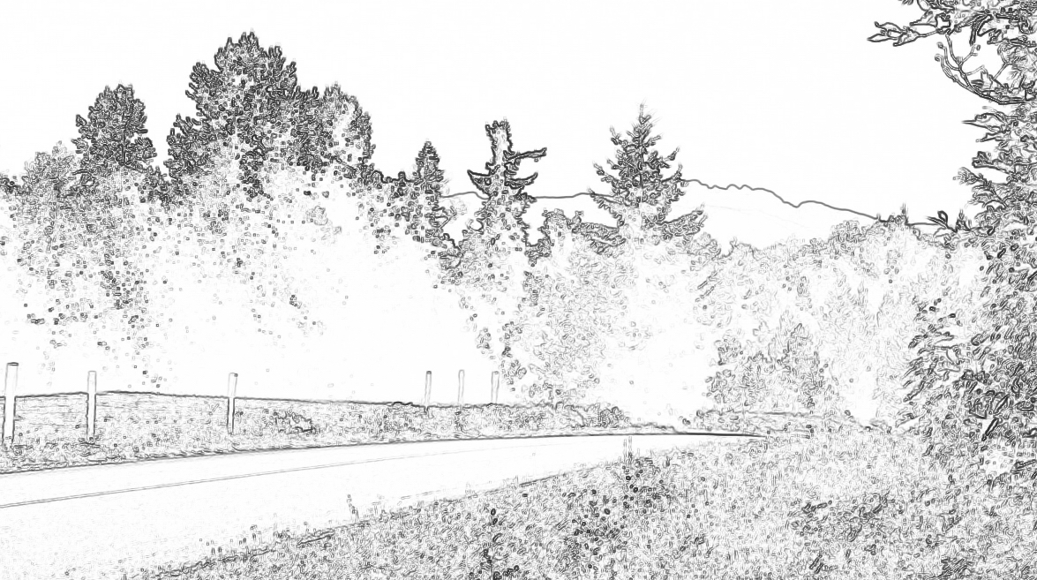

Agenda for 3rd Annual General Meeting – Sunday, October 21st, 2012
10:00 a.m. at the Lighthouse Community Hall
240 Lions Way, Qualicum Bay, B.C.

- Call Meeting to Order
- Approval of the Agenda
- Approval of the Minutes from the 2nd Annual General Meeting held Saturday, October 2nd, 2011
- President’s Report - Elaine Peligren
- Treasurer’s Report - Gerry Anderson
- Approval of the 2012-2013 Annual Registration Fee
 | - Presentation on our Proposed Meadowood Community Park  - Presentation on Little Qualicum River Regional Park |  | Elaine McCullough, RDN  David Palidwor, RDN
Break |  | 15 minute break
 | - Presentation  - Presentation on the Proposed Highway 19 Corcan Interchange  - Presentation - Elected Area “H”  - Presentation - Elected Area “F” |  | Elected MLA Scott Fraser  David Jones & Tim Peligren  Director, William (Bill) Veenhof  Director, Julian Fell
- Questions from the Floor
- Election of Officers & Council Members ( three vacant positions)
- Closing Remarks & Adjournment

